1.Extract the Edog.rar to your TF card, then insert in the TF card slot in the left of the Rearview.
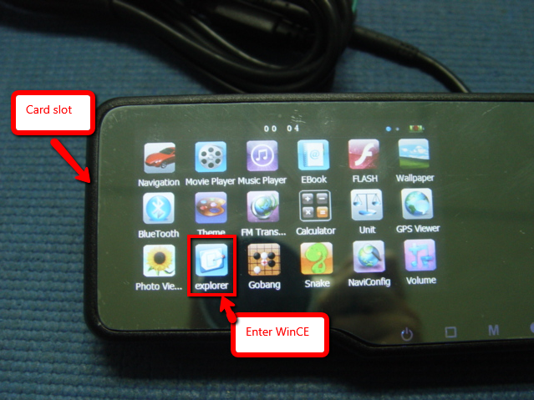
2.Enter the WINCE, open My device-> SDMMC->Copy the folder Edog-> Past it in the resident flash->click the Exit on the desktop, the machine will restart.
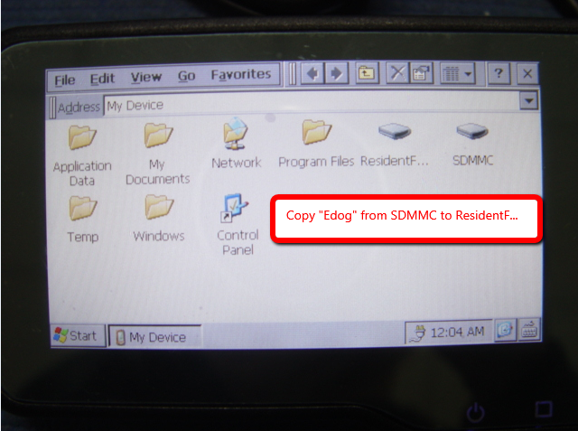
3.Re setup the Navi path, run the navigation. At the first time, it will show notice just press OK.
That’s all.

