- please accept the software (can’t change file name) on the computer and copy it into empty USB (without any file)
- keep the portable DVD charging ,and power on it, and open the disc case (don’t put any DVD disc, holding the disc case ‘s open)
- insert the USB which have software
- press remote “USB/DVD”:
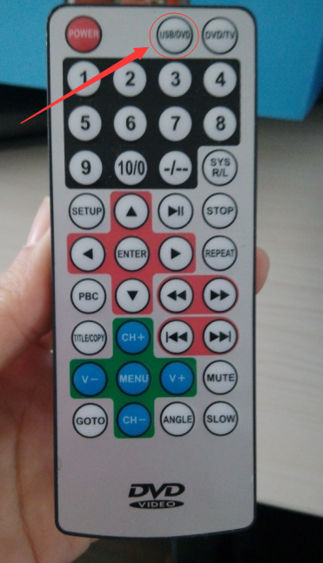
The portable dvd will appear
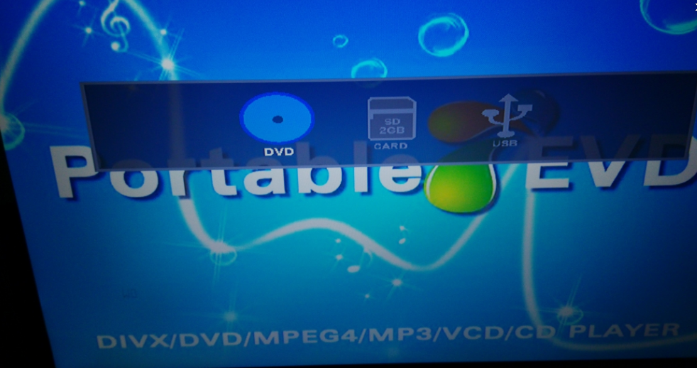
And press remote “>” 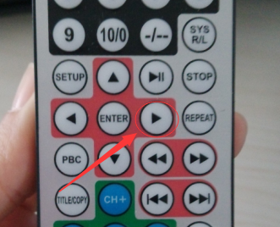
Mote to USB: 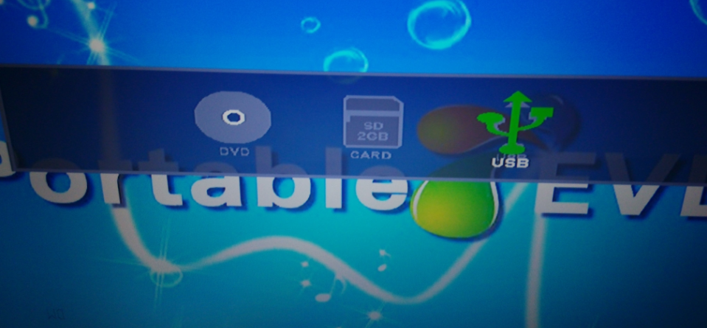
And press remote ”enter”: 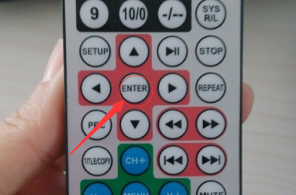

- You will see display appear black ,let it countdown ,waiting until the display reappear normal opening picture.
- Try put DVD disc again

