1. Extract all the WinRAR archive, open SPMultiPortFlashDownloadProject
2. File->Open download agent file->MTK_AllInOne_DA
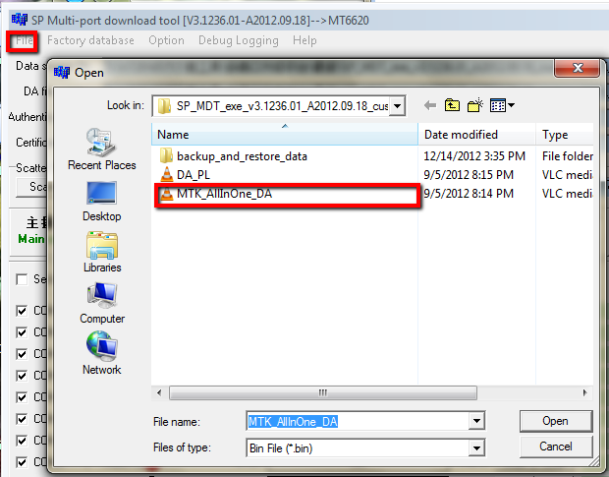
Factory database->Setup data source file->MTK_DATABASE
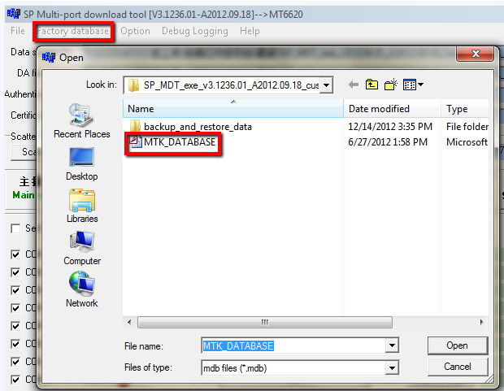
Scatter file->MT6589_Android_scatter_emmc
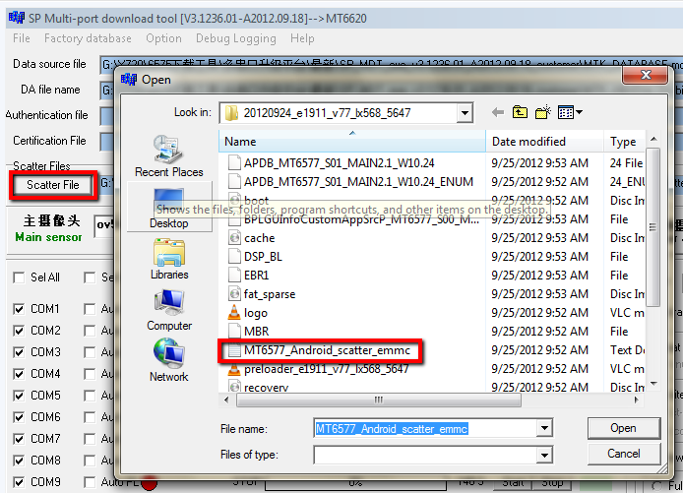
Click the Preloader--->DA
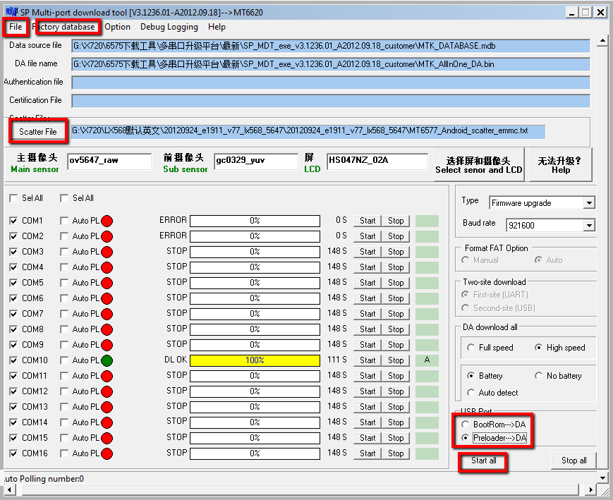 Press start all at last.( Photos are for reference only)
3. Connect the phone and pc with USB cable, it will automatic update.
The first time connect, it will ask the driver, install it from the folder ”Driver”
If update done, it will show DL OK and yellow color.
