- Make sure USB debugging option is enabled under Settings > Development options menu
- Turn off the device
- Press and hold the Volume+ button
- While still holding the button connect the Ceros tablet to a PC via USB cable.
- At first time a popup window appears, with notification about new device and searching for drivers (if it does not happen, press the reset button, otherwise you can release the BACK button)
- Browse for drivers under “Driver” folder. Drivers are included for x86 and x64 architect for different operating systems. Choose correct driver folder according to your operating system and complete driver installation.
- Start “RKBatchTool.exe” software in BatchTool folder. If the driver installation was correct and the Ceros tablet is recognized, then the “1” will turn GREEN. 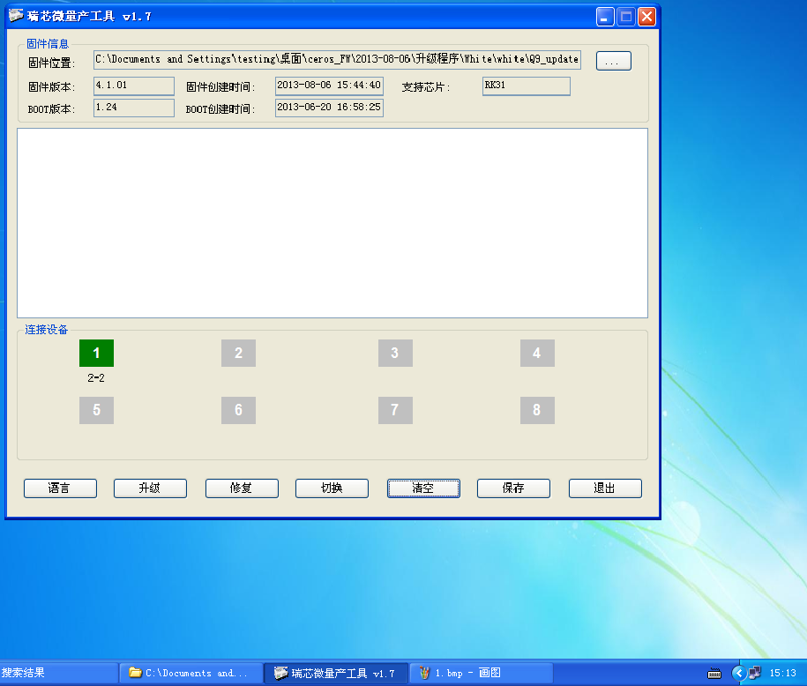
- Click on “. . .” button and browse for the “.img” file (eg: update.img or Q9_update_FT5406_20130806.img).
- Click the third button “修复” to start the firmware installation process. When done, a line green highlighted line appears.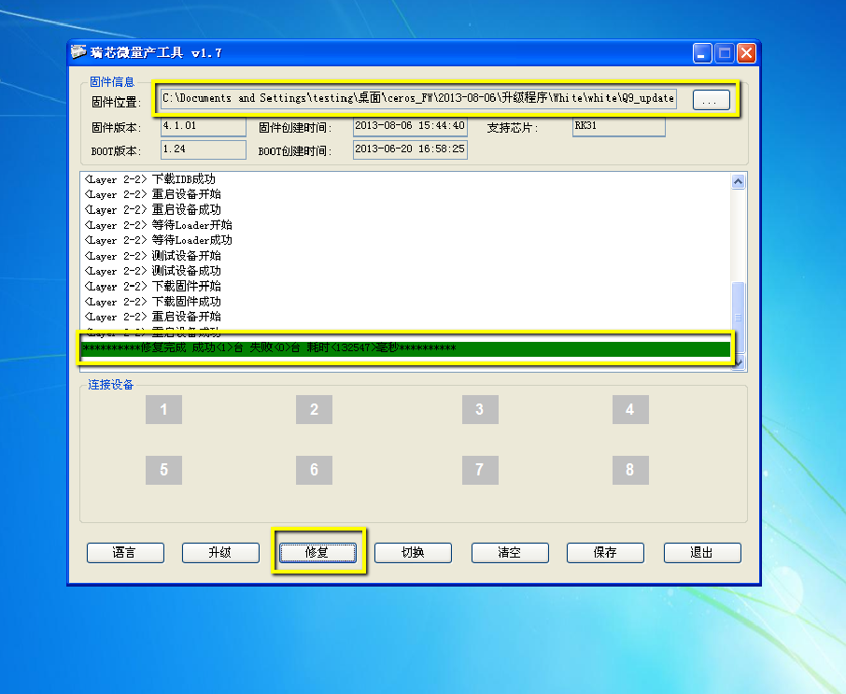
- The device will turn on automatically. note: The first start-up after the upgrade may take a longer time.

